CPS 501 **Assignment 11**

Assigned: 05/04/2020. Due: 05/08/2020, 11 pm (on Isidore).

Instructor: Tamisra H. Sanyal

1. We are going to implement a Java class for graphs based on adjacency lists. We require that each node is associated with an ID which is an integer number. Therefore, the nodes in an adjacency list should be of the type

class EndNode

{

int end_node_id;

EndNode next;

}

1. Please implement a method for performing a BFS on the graph, it should be a nonstatic method in the graph class and returns a queue which keeps the resulting sequence. Hint: You need to additionally implement a class for queues.
2. Please test your BFS method on the following graph. You may start at the node 3.

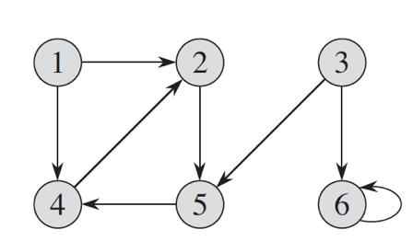

1. Please write another test case for the following graph, you may start at the node 6.

